PROJECT REPORT OF CO-OP Project at Industry (Module-2)
ON
Dossiera
submitted in partial fulfilment of the requirements for the award of degree of

BACHELOR OF ENGINEERING
In
COMPUTER SCIENCE AND ENGINEERING

Submitted by: Supervised By:
Rishika Pawar Nitin Shrivastav
2210992165 Domain Manager
Orange Business


DEPARTMENT OF COMPUTER SCIENCE AND ENGINEERING

CHITKARA UNIVERSITY INSTITUTE OF ENGINEERING AND TECHNOLOGY
CHITKARA UNIVERSITY, PUNJAB, INDIA

CONTENTS

S.No. | Title | Page No.
 | Acknowledgement | iv
 | List of Figures and Tables | v
 | Abstract
1 | Introduction | 06
2 | Methodology | 07
3 | Tools and Technologies | 07
4 | Implementation | 07-08
5 | Major Findings/Outcomes/Output/Results | 09
6 | Conclusion and Future Scope | 09
 | References
 | Appendices

DECLARATION

I hereby certify that the work which is being presented in the project report entitled “Dossiera” in partial fulfilment of requirement for the award of the degree of Bachelor of Engineering (Computer Science and Engineering) submitted in the department of Computer Science and Engineering at Chitkara University Institute of Engineering and Technology, Chitkara University, Punjab, India, is an authentic record of my own work carried out under the supervision of Dr.Ashish Kumar. The matter presented in this project report has not been submitted in any other university/institute for the award of any degree.

Place: Rajpura Rishika Pawar
Date: 30 April 2026 2210992165

This is to certify that the above statement made by the candidate is correct to the best of my knowledge and belief.

Dr. Ashish Kumar
Associate Professor-Head Operations
Department of Computer Science and Engineering
Chitkara University Institute of Engineering and Technology,
Chitkara University, Punjab, India

ACKNOWLEDGEMENT

This project presents a resume analysis platform designed to automate resume screening. The application extracts key details such as skills, education, and experience from resumes and compares them with job descriptions to generate a skill match score. It uses document parsing and keyword-based matching techniques for analysis. AI APIs are integrated to generate resume summaries and provide skill insights. The platform helps improve recruitment efficiency and reduces manual screening effort.

Abstract

Dossiera is a production-ready Applicant Tracking System (ATS) optimization platform that leverages Generative AI to analyze, score, and summarize resumes based on specific job roles. The system extracts key candidate details such as skills, contact information, and experience, and evaluates them against job descriptions to generate an AI-based match score.
It integrates advanced AI models to provide intelligent insights, resume improvement suggestions, and candidate suitability summaries. The platform also includes automated email functionality for recruiter communication and a secure authentication system. Dossiera significantly reduces manual screening effort and enhances recruitment efficiency through automation and intelligent decision-making.

Introduction

With the rapid growth of digital recruitment platforms, organizations face challenges in efficiently screening large volumes of resumes. Traditional methods are time-consuming, inconsistent, and prone to human error.
Dossiera addresses these challenges by introducing an AI-powered talent intelligence platform that automates resume analysis and candidate evaluation. The system helps recruiters identify the best-fit candidates quickly and accurately using AI-driven insights and match scoring.

Methodology

- Resume Upload by user (PDF/DOC)
- Resume Parsing using extraction libraries
- Data Cleaning & Structuring
- Skill & Information Extraction
- Job Description Input
- AI-based Resume Analysis using Gemini
- Match Score Calculation (0–100%)
- Resume Summary Generation
- Dashboard Display & Email Notification

Tools and Technologies

Category | Technology
Frontend | Next.js 14, Tailwind CSS, ShadCN UI
Backend | Node.js, Next.js API Routes
Database | MongoDB Atlas
AI Integration | Google Gemini 1.5 Flash
Authentication | NextAuth.js (Google OAuth)
Validation | Zod
Email Service | Nodemailer

Implementation

The system is divided into multiple modules:
1. Client (Frontend)
- Built using Next.js SPA architecture
- Provides recruiter dashboard
- Allows resume upload and job role management

2. Server (Backend API)
- RESTful API using Next.js routes
- Handles requests, scoring, and AI integration
- Includes unified error handling

3. Resume Processing Module
- Extracts text from uploaded resumes
- Identifies:
  - Name
  - Email
  - Skills
  - Experience
4. AI Intelligence Module
- Uses Google Gemini API
- Generates:
  - Resume summaries
  - Skill insights
  - Candidate suitability

5. Match Scoring Engine
- Compares resume skills with job description
- Calculates percentage match score

6. Email Automation Module
- Uses Nodemailer
- Sends:
  - Interview emails
  - Rejection emails

7. Authentication & Security
- Google OAuth via NextAuth
- Data validation using Zod

System Architecture

Dossiera follows a decoupled architecture:
- Client Layer: User Interface (Next.js)
- Server Layer: API & Logic Handling
- Database Layer: MongoDB Atlas
- AI Layer: Gemini API Integration

Key Features (Academic Format)
- AI-based resume match scoring (0–100%)
- Automated skill and information extraction
- AI-generated resume summaries and insights
- Recruiter dashboard for candidate management
- Automated email communication system
- Secure authentication using Google OAuth
- Scalable and modular architecture

Major Findings / Results
- Reduced resume screening time significantly
- Improved accuracy in candidate shortlisting
- Automated communication streamlined hiring process
- AI insights enhanced recruiter decision-making
- System handled multiple resumes efficiently

Conclusion
Dossiera successfully demonstrates the implementation of an AI-powered ATS optimization platform. It automates resume analysis, improves hiring efficiency, and reduces manual workload. The integration of AI enables intelligent decision-making and enhances the overall recruitment process.

Future Scope
- Integration with job portals (LinkedIn, Naukri)
- Use of NLP for semantic skill matching
- Candidate ranking system with advanced ML models
- Real-time analytics dashboard
- Multi-language resume support

Appendix

- Home page
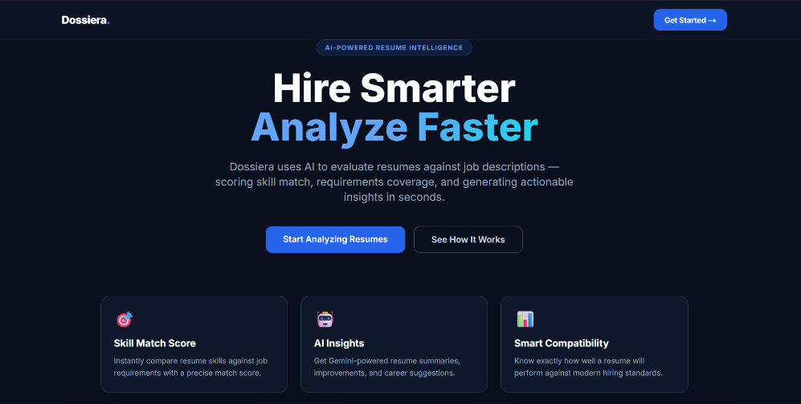
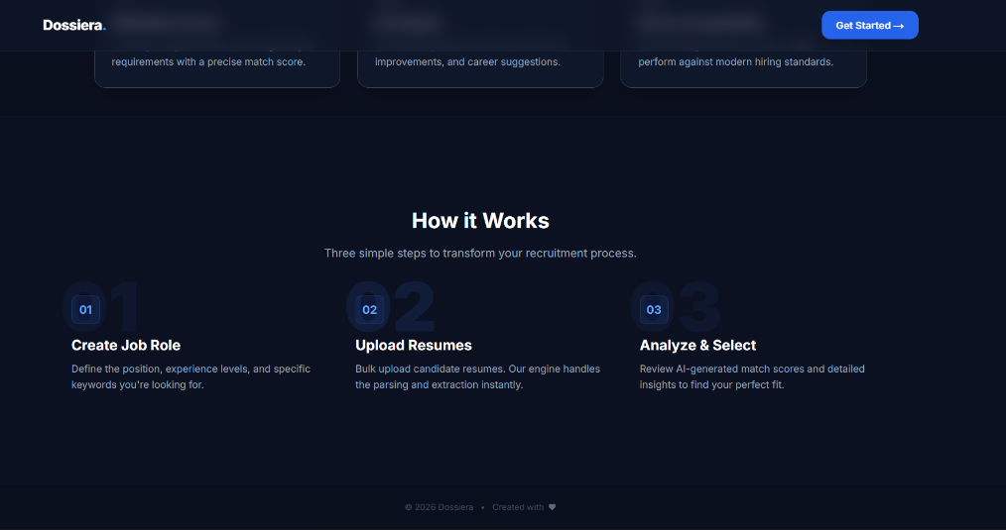

- Signup page
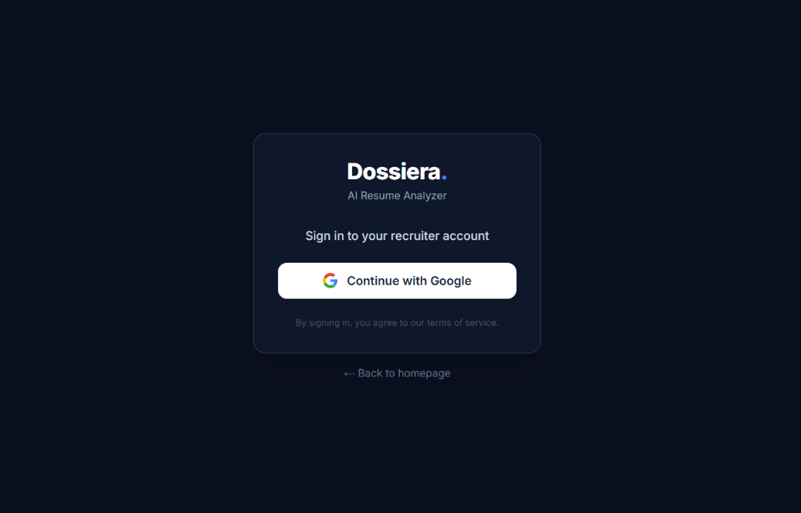
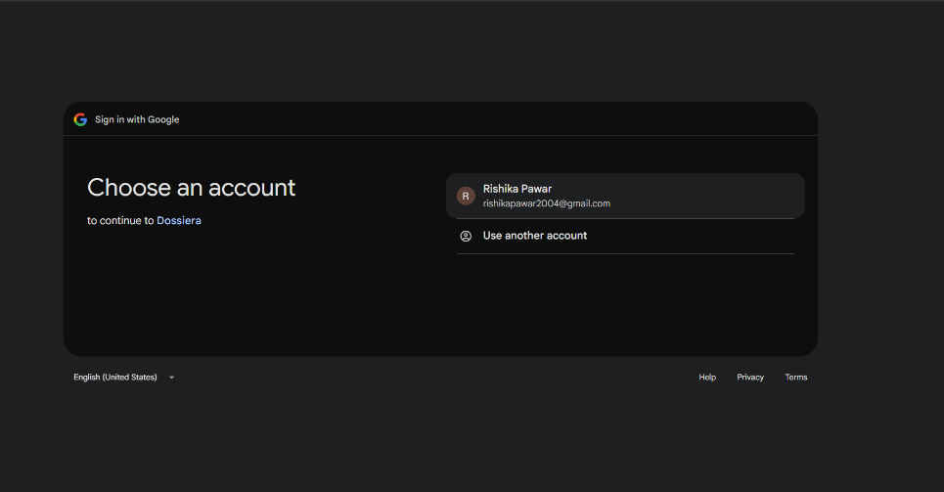

- Dashboard
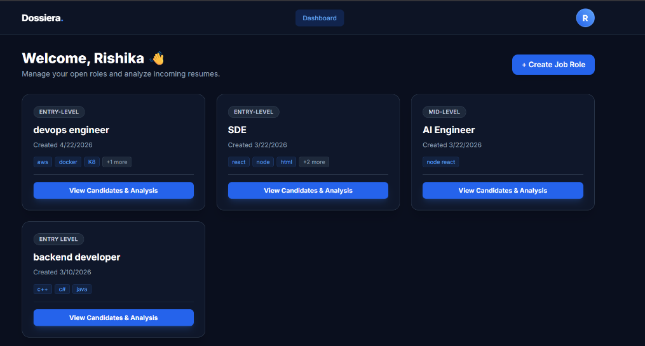

- Create job role
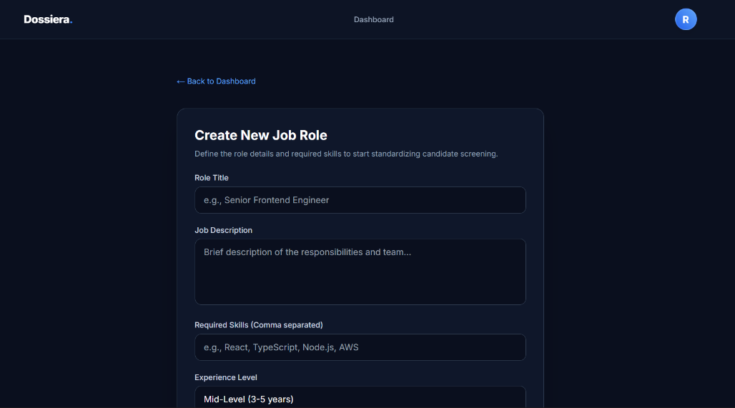

- View candidates and analysis
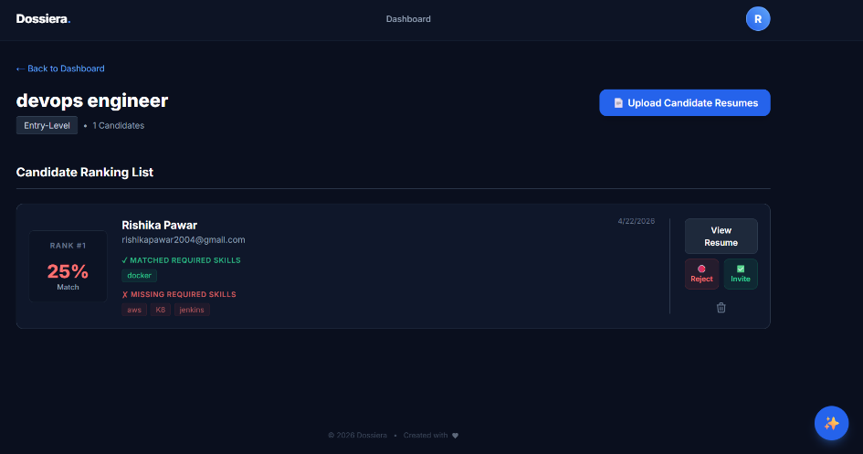

- AI chat box
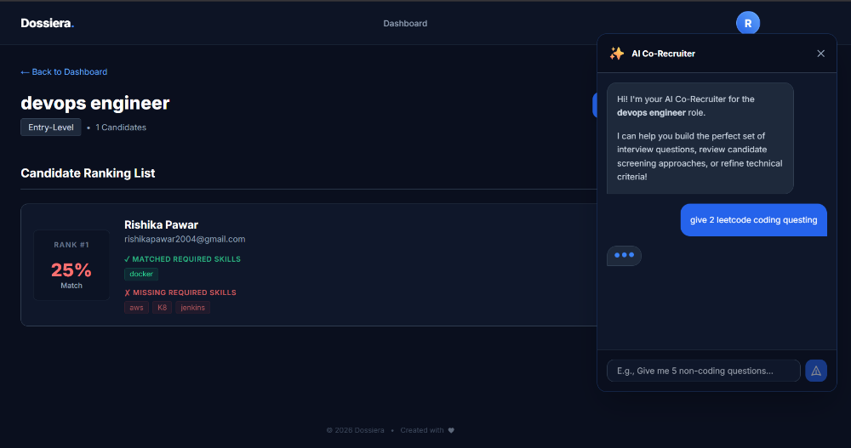
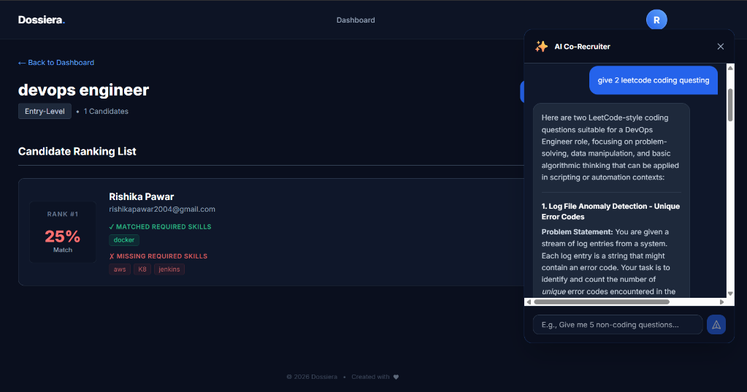

- Profile button
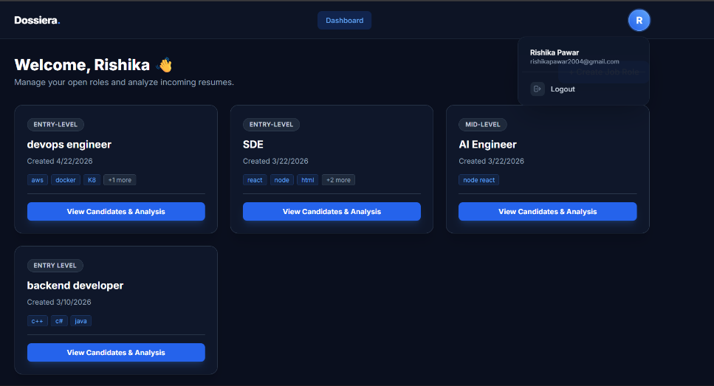

- Sending invite to candidate through email
